Procedure:-

Step1:-Go to manage jenkins then enter an item name project_pakage.Select Freestyle Project.

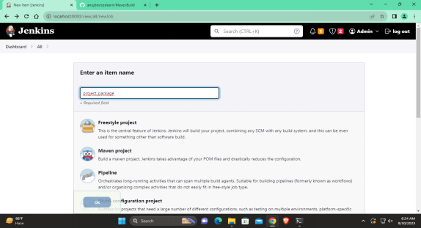

Step2:-In build steps select invoke top-level Maven target in that maven version would be mymaven and in goals package.

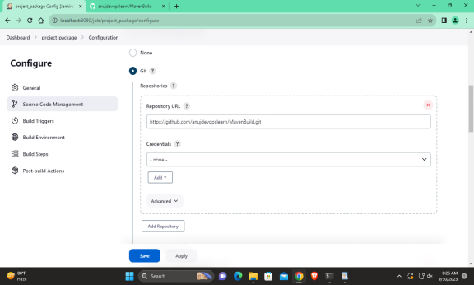

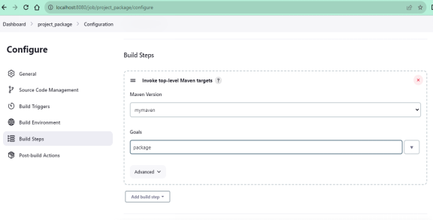

Step3 In Post Build actions in that project_package would be there and select trigger only if build is stable. Then apply and save.

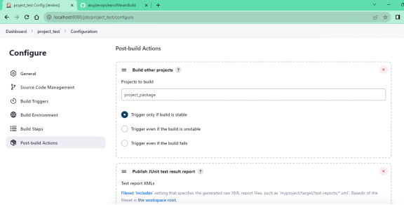

Step4:-Now UPSTREM the project do same project as project_test.Now built it.If have to see workspace click on project.

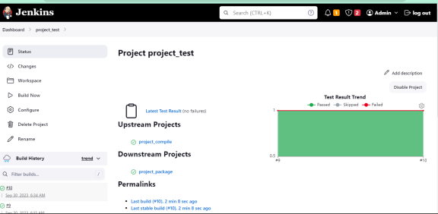

Step5:-Go to the dashboard in that select new view name it as devops CICD pipeline and in type select build pipeline view and create it.

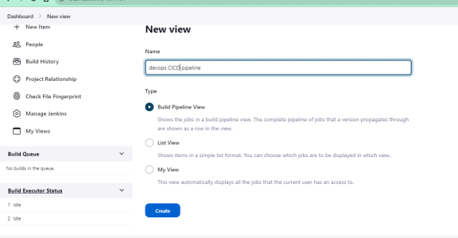

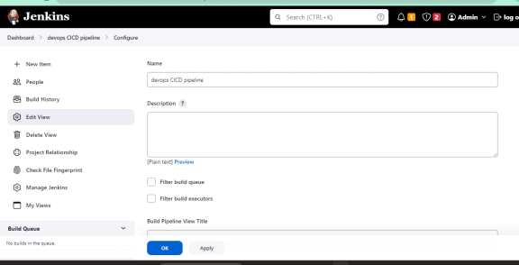

Step6:Apply and ok.

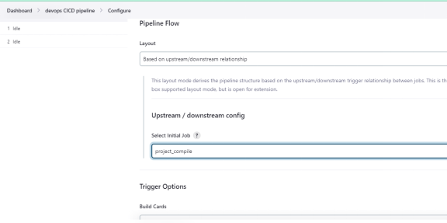

Step7:After applying the above build pipeline the following would be the output.

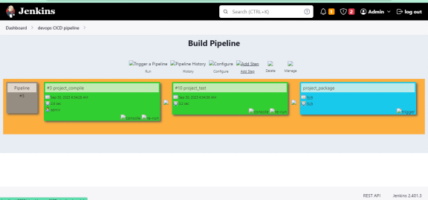

Step8:-If you want more pipelines then increase the no of displayed builds.

